**Determination of ATPase flux from measurements with stoichiometric model**

All calculations were performed with MATLAB (v R2020b) and the Toolbox *CellNetAnalyzer* (version 2020.3) and the deposited stoichiometric model of *E. coli*’s central carbon metabolism. The model is based on the one described in (Hädicke & Klamt, 2017) and was modified only by an additional growth reaction for anaerobic growth.

In total, 96 calculations have been performed: 8 strains, each under aerobic/anaerobic conditions, each with and without growth and measured in triplicates (8*2*2*3). After determination of the ATPase flux (ATPM reaction) for every replicate for the respective strain and cultivation condition (as described below), means ± s.d. were calculated for each of the 8*2*2 scenarios (which can be found in the tables of the main manuscript and the Appendix).   
As an example for how to determine the ATPase flux for a given condition, we use the rates of replicate 1 of the MC ATPase strain for aerobic and then for anaerobic conditions (as the calculation differs slightly for aerobic/anaerobic conditions).

Case 1 - Aerobic with growth (shown for MC ATPase replicate 1):

1. Load the standard glucose scenario and add the experimentally determined glucose uptake rate, growth rate and specific acetate productivity (scenario “aerobic_MC ATPase rep1.val”)  
   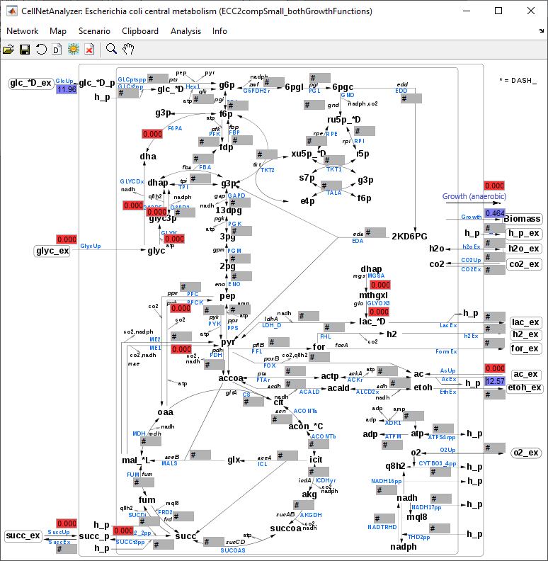
2. Use flux optimization tool of *CNA* with ATPM as objective function  
   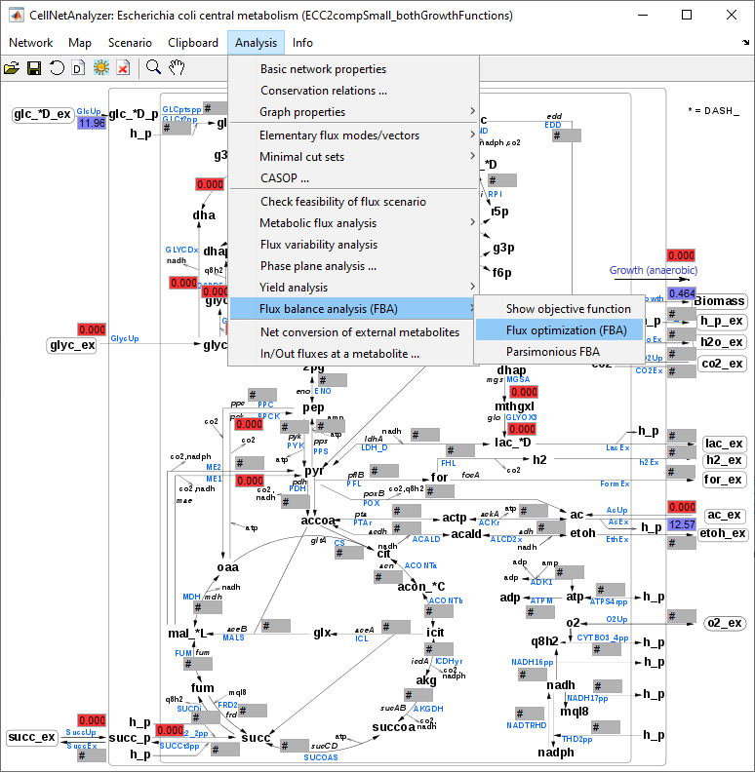
3. The ATPase flux is calculated by *CNA* (scenario “aerobic_MC ATPase rep1_after optimization.val”)  
   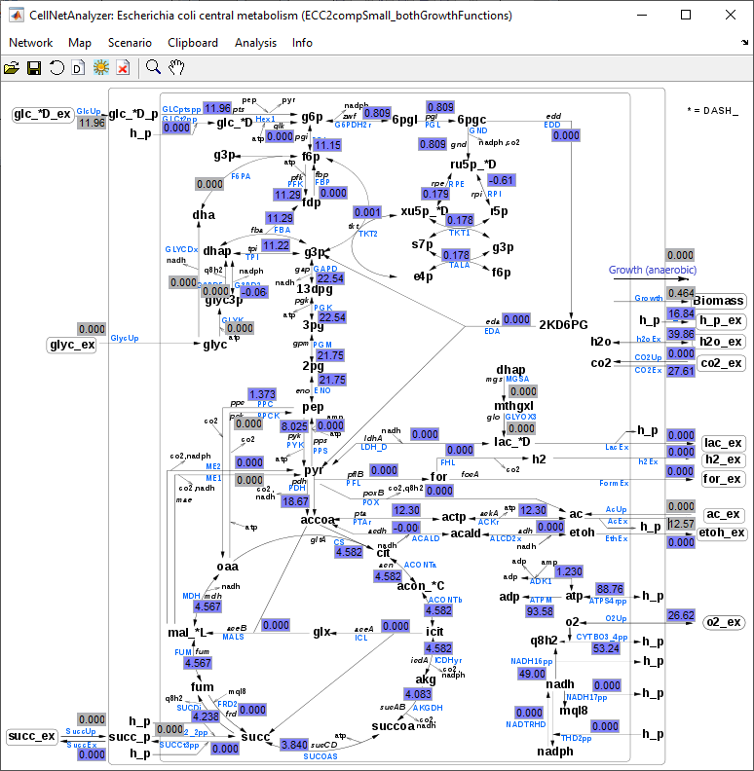

Case 2 - Anaerobic with growth (shown for MC ATPase replicate 1):

1. Load the standard glucose scenario, set the oxygen exchange rate to zero and add the experimentally determined glucose uptake rate, growth rate (note: for anaerobic cultivation, use the anaerobic growth function and set the other growth function to zero) and specific acetate, ethanol, formate, lactate, and succinate productivities (scenario “anaerobic_MC ATPase rep1.val”)  
   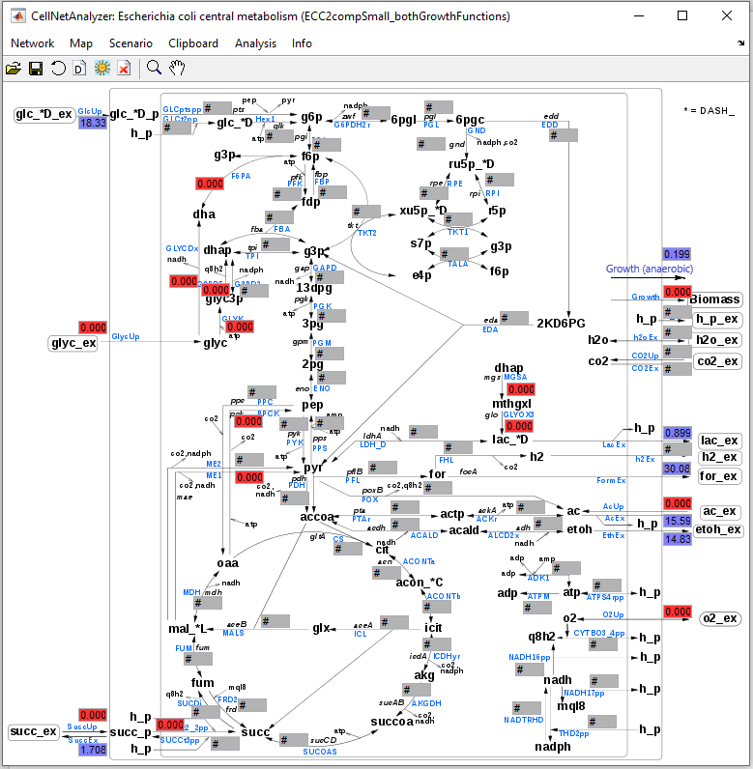
2. Use “Check feasibility of flux scenario” function of *CNA*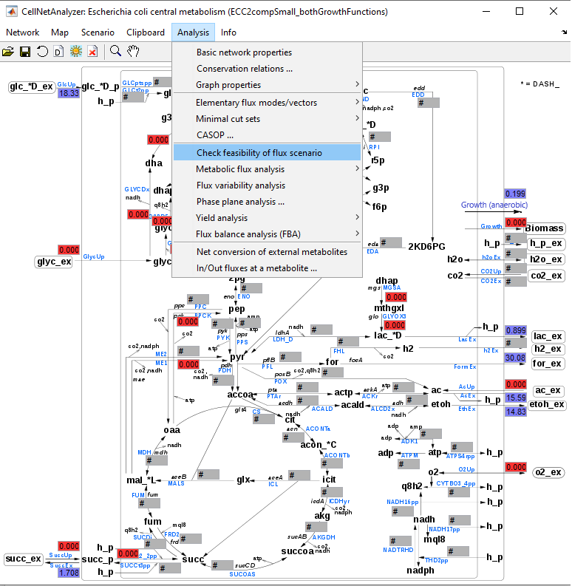
3. Copy the modified glucose uptake rate  
   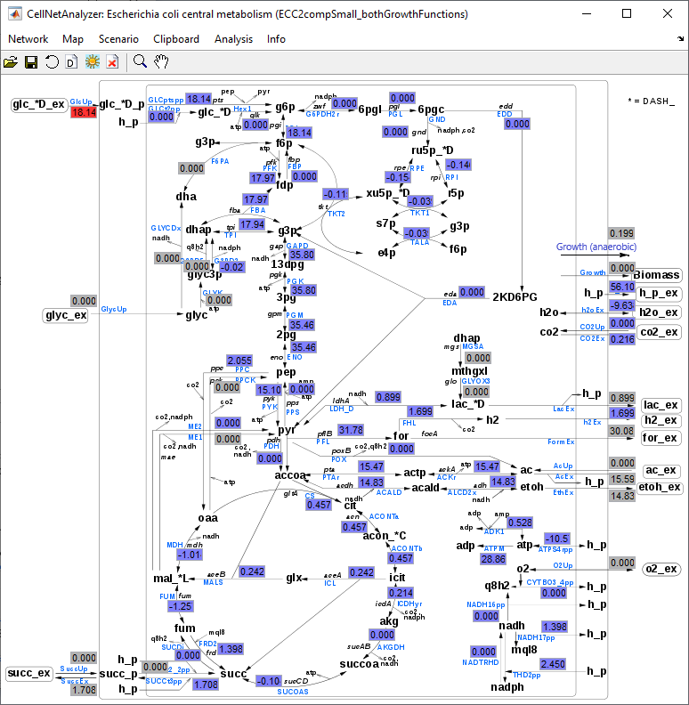
4. Copy the corrected glucose uptake rate, use the “reset last scenario” arrow (or select this from Scenario menu) and replace the glucose uptake rate by the corrected rate and delete the values in the succinate excretion box (scenario “anaerobic_MC_ATPase_rep1_after_modification.val”). This is done to make the scenario non-redundant (otherwise, FBA may run into numerical problems). As you will see below, the rate calculated for succinate via FBA will be close to the originally measured one.

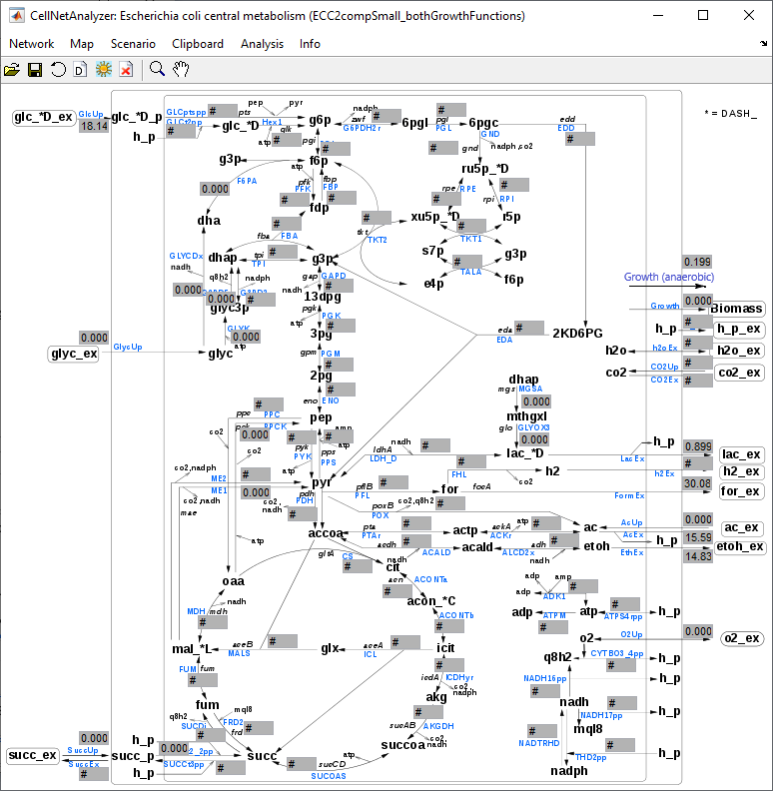

1. Use flux optimization tool of *CNA* with ATPM as objective function  
   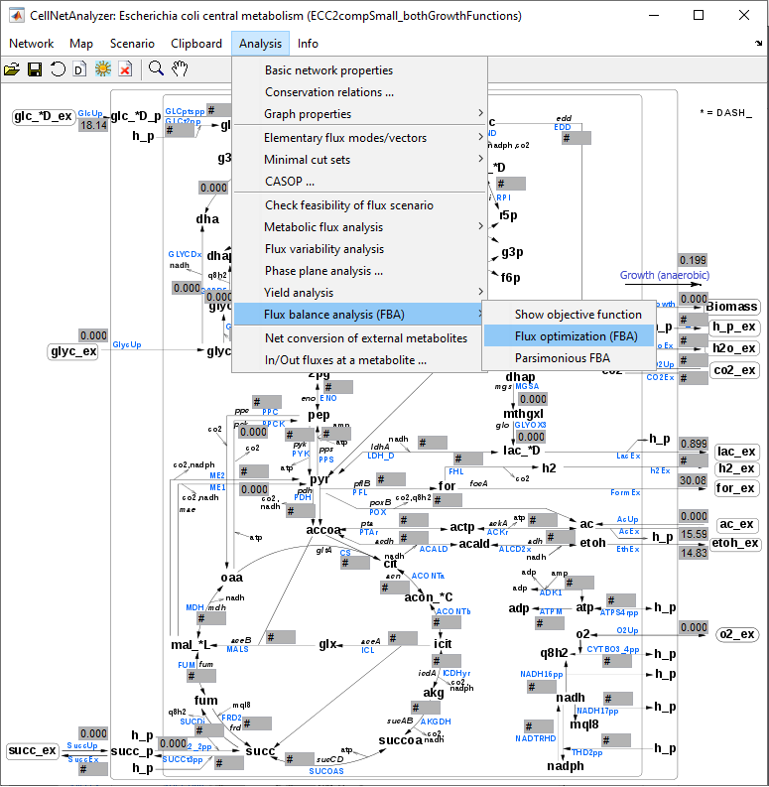
2. The ATPase flux is calculated by *CNA* (scenario “anaerobic_MC ATPase rep1_after optimization.val”)  
   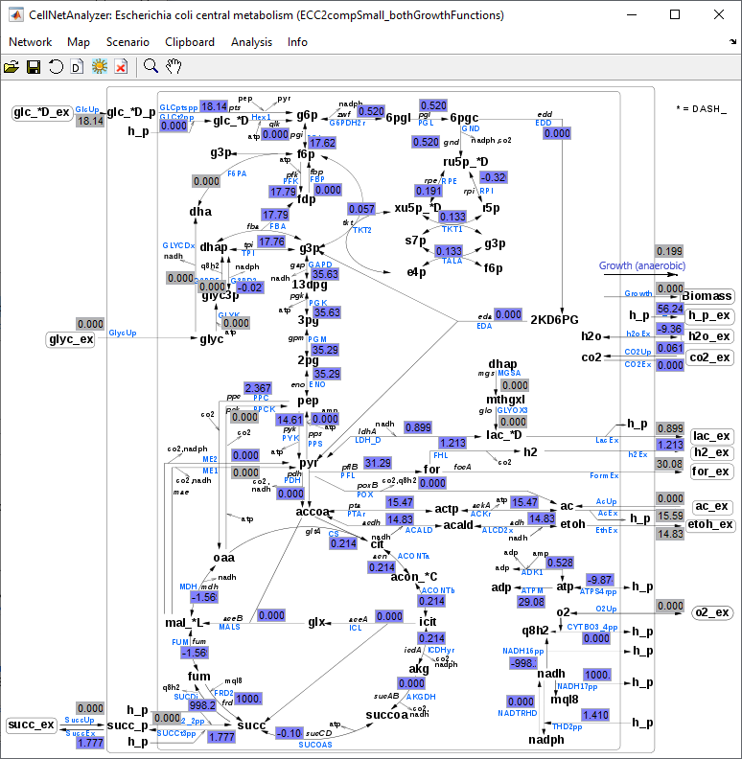

Case 3 – Aerobic and anaerobic cultivation with growth arrest:

Follow the instructions described above but set the growth rate to zero. Again, modifying the glucose uptake rate for the anaerobic case is not necessary.

References

Hädicke O, Klamt S (2017) EColiCore2: a reference network model of the central metabolism of *Escherichia coli* and relationships to its genome-scale parent model. *Sci Rep* 7: 39647